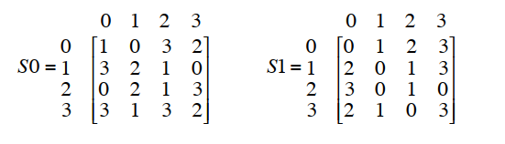   
  
P = 7351624  
P- = 4627351   
  
Methods  
P- = HDESTOM  
  
  
  
  
1010  
10 = 2  
01 = 1  
  
**Answer**: 00  
  
1100  
10 = 2  
10 = 2  
  
**Answer**: 01  
  
0011  
01 = 1  
01 = 1  
  
**Answer**: 00  
  
Total: 00 01 00  
  
  
P10 **3 5 2 7 4 10 1 9 8 6**

|  |  |  |  |  |  |  |  |  |  |
| --- | --- | --- | --- | --- | --- | --- | --- | --- | --- |
| **1** | **2** | **3** | **4** | **5** | **6** | **7** | **8** | **9** | **10** |
| **1** | **1** | **0** | **1** | **0** | **0** | **1** | **1** | **0** | **0** |

**Output: 1101001100**

LS-1

**LH:**

**11010**

**RH:**

**01100  
-----------  
LH [left]:** 10101

**RH[left]:** 11000

**P8**

6 3 7 4 8 5 10 9

Input: 10101 11000

|  |  |  |  |  |  |  |  |
| --- | --- | --- | --- | --- | --- | --- | --- |
| 1 | 2 | 3 | 4 | 5 | 6 | 7 | 8 |
| 1 | 1 | 1 | 0 | 0 | 1 | 0 | 0 |

**K1:** 1110 0100

**LS-2**  
10101 11000 [part 2 output]

LS2 [output]: 10110 00011

**P8-2**

P8: 6 3 7 4 8 5 10 9

Input: 10110 00011 [LS-2 Output]

|  |  |  |  |  |  |  |  |
| --- | --- | --- | --- | --- | --- | --- | --- |
| 1 | 2 | 3 | 4 | 5 | 6 | 7 | 8 |
| 0 | 1 | 0 | 1 | 0 | 0 | 1 | 1 |

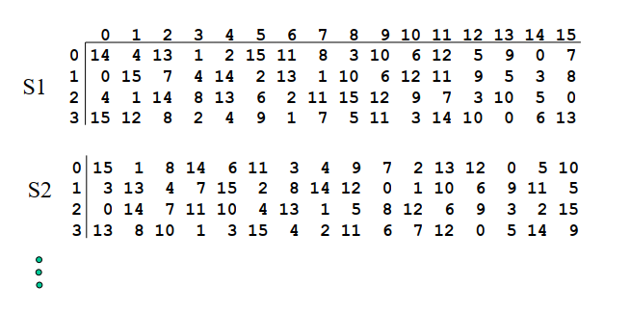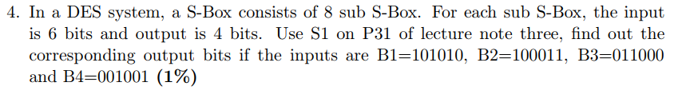**K2:** 01010011  
  
**Answer:**  
**K1:** 1110 0100  
**K2:** 0101 0011  
  
  
  
  
  
  
  
  
  
  
  
  
  
  
  
  
  
  
  
  
  
  
  
  
  
  
B1: 101010  
10 = 2  
0101 = 5  
Answer: 0110  
  
B2: 100011  
11 = 3  
0001 = 1  
Answer: 1100

B3: 011000  
00 = 0  
1100 = 12  
Answer: 0101  
  
  
  
  
B4: 001001  
01 = 1  
0100 = 4  
Answer: 1110

0110 1100 0101 1110  
  
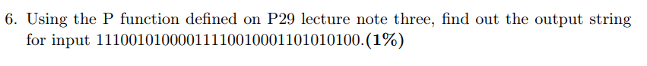  
  
*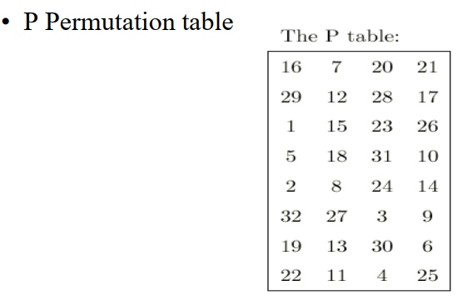  
Start from first row, move to end of row; then go down*

|  |  |  |  |  |  |  |  |  |  |  |  |  |  |  |  |  |  |  |  |  |  |  |  |  |  |  |  |  |  |  |  |
| --- | --- | --- | --- | --- | --- | --- | --- | --- | --- | --- | --- | --- | --- | --- | --- | --- | --- | --- | --- | --- | --- | --- | --- | --- | --- | --- | --- | --- | --- | --- | --- |
| 1 | 2 | 3 | 4 | 5 | 6 | 7 | 8 | 9 | 10 | 11 | 12 | 13 | 14 | 15 | 16 | 17 | 18 | 19 | 20 | 21 | 22 | 23 | 24 | 25 | 26 | 27 | 28 | 29 | 30 | 31 | 32 |
| **1** | **1** | **1** | **0** | **0** | **1** | **0** | **1** | **0** | **0** | **0** | **0** | **1** | **1** | **1** | **1** | **0** | **0** | **1** | **0** | **0** | **0** | **1** | **1** | **0** | **1** | **0** | **1** | **0** | **1** | **0** | **0** |

**Output:** 1000 0010 1111 0000 1111 0010 1111 0000